#发现ISCSI存储

iscsiadm -m discovery --type sendtargets --portal 10.0.11.5:3260

iscsiadm -m discovery --type sendtargets --portal 10.0.12.5:3260

#登陆ISCSI存储

iscsiadm -m node –login

1. **检查iscsi rpm包**

rpm -qa | grep iscsi

安装rpm包

[root@qionghai11g Packages]# rpm -Uvh iscsi-initiator-utils-6.2.0.873-2.el6.x86_64.rpm

[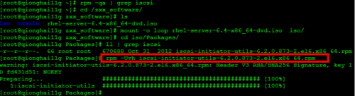](http://jingyan.baidu.com/album/915fc414eb528d51394b20cc.html?picindex=1)

1. **启动iscsi服务并设置开机自启动**

[root@qionghai11g Packages]# service iscsi start

[root@qionghai11g Packages]# chkconfig --list | grep iscsi

[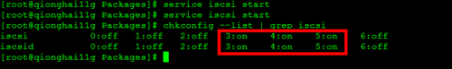](http://jingyan.baidu.com/album/915fc414eb528d51394b20cc.html?picindex=2)

1. **查找存储对外提供的逻辑卷**

[root@qionghai11g ~]# iscsiadm -m discovery -t sendtargets -p 192.16.10.188:3260

Starting iscsid:                                           [  OK  ]

192.16.10.188:3260,1 iqn.2004-01.com.storbridge:block02-wt

192.16.10.188:3260,1 iqn.2004-01.com.storbridge:block01-wt

[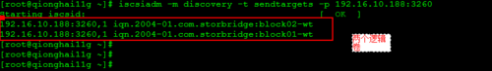](http://jingyan.baidu.com/album/915fc414eb528d51394b20cc.html?picindex=3)

1. **映射逻辑卷到Linux系统中**

**[root@qionghai11g ~]# iscsiadm -m node -T iqn.2004-01.com.storbridge:block01-wt -p 192.16.10.188:3260 -l**

Logging in to [iface: default, target: iqn.2004-01.com.storbridge:block01-wt, portal: 192.16.10.188,3260] (multiple)

Login to [iface: default, target: iqn.2004-01.com.storbridge:block01-wt, portal: 192.16.10.188,3260] successful.

**[root@qionghai11g ~]# iscsiadm -m node -T iqn.2004-01.com.storbridge:block02-wt -p 192.16.10.188:3260 -l**

Logging in to [iface: default, target: iqn.2004-01.com.storbridge:block02-wt, portal: 192.16.10.188,3260] (multiple)

Login to [iface: default, target: iqn.2004-01.com.storbridge:block02-wt, portal: 192.16.10.188,3260] successful.

[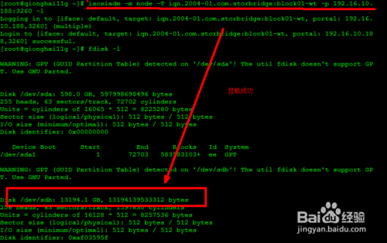](http://jingyan.baidu.com/album/915fc414eb528d51394b20cc.html?picindex=4)

1. **设置开机自动映射**

**[root@qionghai11g ~]#** **iscsiadm -m node -T iqn.2004-01.com.storbridge:block02-wt -p 192.16.10.188:3260 --op update -n node.startup -v automatic**

**[root@qionghai11g ~]# iscsiadm -m node -T iqn.2004-01.com.storbridge:block01-wt -p 192.16.10.188:3260 --op update -n node.startup -v automatic**

**这两个是开机自动映射**

1. **对映射出来的磁盘进行分区**

**由于存储容量是12T 大于2T，不能用不同分区 fdisk ，只能用GPT分区**

**parted /dev/sdb  对/dev/sdb进行分区**

**print     打印信息，从中可以看出这个磁盘大小和分区格式**

**mklabel gpt**

**mkpart primary 0% 100%**

**print    从中可以看出这个磁盘分区格式已经变了成GPT了**

[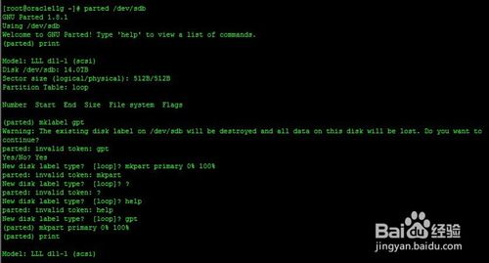](http://jingyan.baidu.com/album/915fc414eb528d51394b20cc.html?picindex=5)

1. **分区之后进行格式化**

[root@oracle11g ~]# mkfs.ext3 /dev/sdb

mke2fs 1.39 (29-May-2006)

/dev/sdb is entire device, not just one partition!

Proceed anyway? (y,n) y

Filesystem label=

OS type: Linux

Block size=4096 (log=2)

Fragment size=4096 (log=2)

1708998656 inodes, 3417968064 blocks

170898403 blocks (5.00%) reserved for the super user

First data block=0

Maximum filesystem blocks=4294967296

104309 block groups

32768 blocks per group, 32768 fragments per group

16384 inodes per group

Superblock backups stored on blocks:

         32768, 98304, 163840, 229376, 294912, 819200, 884736, 1605632, 2654208,

         4096000, 7962624, 11239424, 20480000, 23887872, 71663616, 78675968,

         102400000, 214990848, 512000000, 550731776, 644972544, 1934917632,

         2560000000

Writing inode tables: done

Creating journal (32768 blocks): done

Writing superblocks and filesystem accounting information: done

done

This filesystem will be automatically checked every 23 mounts or

180 days, whichever comes first.  Use tune2fs -c or -i to override.

[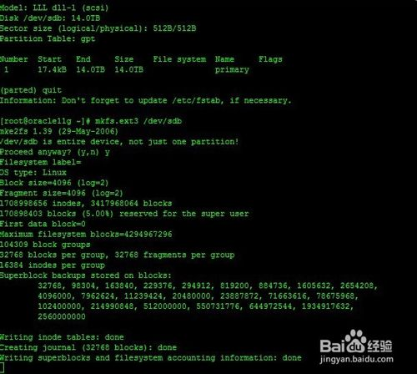](http://jingyan.baidu.com/album/915fc414eb528d51394b20cc.html?picindex=6)

1. **挂载分区**

[root@qionghai11g ~]# cd /var/www/html/

[root@qionghai11g html]# mkdir kk1 kk2

[root@qionghai11g mnt]# mount  /dev/sdb1 /var/www/html/kk1/